National University of Computer and Emerging Sciences

## Assignment 01(Part B)

## Saram Khalil

## 21F-9149

## BCS-6B

# Task 1:

# Build Your Webpage having your name, roll number, and brief about yourself.

1. Style the background color to blue using inline CSS method.

2. Change the font size of the name text to 36px using Internal CSS.

3. Using external CSS methods give shadows to all elements.

## CODE:

## HTML:

<!DOCTYPE html>

<html lang="en">

<head>

    <meta charset="UTF-8">

    <meta name="viewport" content="width=device-width, initial-scale=1.0">

    <link rel="stylesheet" href="style1.css">

    <title>Task 1</title>

    <style>

        h1{

            font-size: 36px;

        }

    </style>

</head>

<body bgcolor="blue">

    <h1 class="h1">Saram Khalil</h1>

    <h2>21F-9149</h2>

    <p>I am currently enrolled in FAST NUCES for BSCS. I am quite good at basic and advanced programming logics.</p>

</body>

</html>

## CSS:

h1{

    text-shadow: 2px 2px white;

}

h2{

    text-shadow: 1px 1px yellow;

}

p{

    text-shadow: 1px 1px red;

}

## Output:

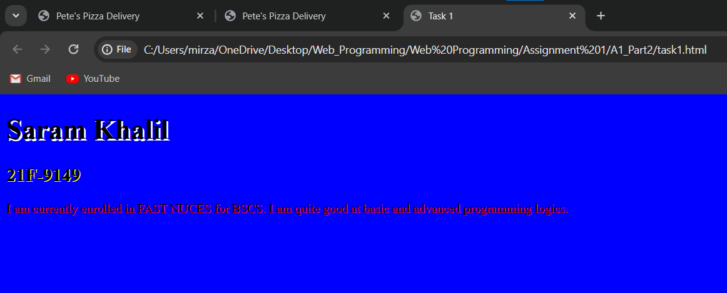

# TASK 2:

## Demonstrate the following output using style on your webpage.

## CODE:

<!DOCTYPE html>

<html lang="en">

<head>

    <meta charset="UTF-8">

    <meta name="viewport" content="width=device-width, initial-scale=1.0">

    <title>Task 2</title>

</head>

<body>

    <div style="background-color: #2C3E50; color: white; padding: 20px;">

        <h1 style="margin: 0;">Start CSS Exercises</h1>

        <p style="margin: 5px 0;">Good luck!</p>

        <button style=" margin-top: 10px; background-color: #27AE60; color: white; border: none; padding: 10px 20px; border-radius: 5px;">

            Start CSS Exercises >

        </button>

    </div>

</body>

</html>

## OUTPUT:

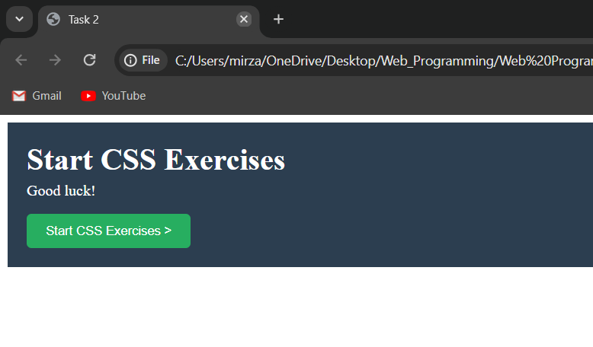

# TASK 3:

## Develop the following form using get method into your webpage.

## CODE:

## HTML:

<!DOCTYPE html>

<html lang="en">

<head>

    <meta charset="UTF-8">

    <meta name="viewport" content="width=device-width, initial-scale=1.0">

    <link rel="stylesheet" href="style3.css">

    <title>Task 3</title>

</head>

<body>

    <div class="abc">

        <h1>Contact Us</h1>

        <form action="get" class="for1">

            <label for="name">Your Name:</label><br>

            <input class="inp" type="text" placeholder="Mirza Sarim"><br>

            <label for="email">Your Email:</label><br>

            <input class="inp" type="email" placeholder="sarim@gmail.com"><br>

            <label for="phone">Your Phone No:</label><br>

            <input class="inp" type="text" placeholder="Format: 123-456-7890" pattern="[0-9]{3}-[0-9]{3}-[0-9]{4}" required><br>

            <label for="msg">Your Message:</label><br>

            <textarea class="inp" placeholder="Type Your Messgae Here..." name="msg" id="" cols="30" rows="4"></textarea><br>

            <button class="btn" type="submit">Submit</button><br>

            <button class="btn" type="reset">Reset</button><br><br>

        </form>

    </div>

</body>

</html>

## CSS:

body{

    background-color: rgb(242,242,242);

}

.abc{

    background-color: white;

    width: 400px;

    margin-left: 30%;

    border-radius: 5px;

    box-shadow: 1px 1px 1px 1px rgb(161, 161, 161);

}

h1{

    text-align: center;

    padding-top: 20px;

    font-family: Arial, Helvetica, sans-serif;

}

.for1{

    margin: 20px 20px;

}

.inp{

    width: 100%;

    margin-top: 2px;

    margin-bottom: 8px;

}

.btn{

    width: 100%;

    margin-top: 10px;

    padding: 5px;

    background-color: rgb(76,175,80);

    color: white;

    border: none;

    border-radius: 2px;

    cursor: pointer;

}

## Output:

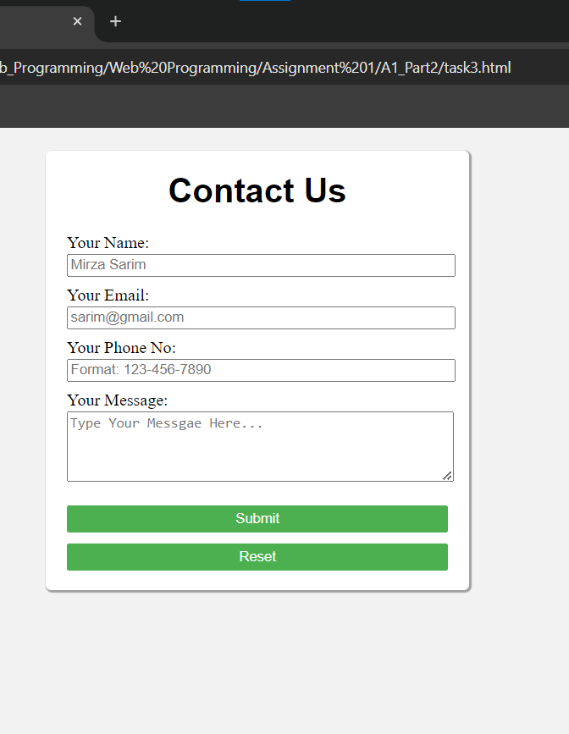

# TASK 4:

## Create the following card (Or like that) in your webpage.

## CODE:

## HTML:

<!DOCTYPE html>

<html lang="en">

<head>

    <meta charset="UTF-8">

    <meta name="viewport" content="width=device-width, initial-scale=1.0">

    <link rel="stylesheet" href="style4.css">

    <title>Task 4</title>

</head>

<body>

    <div class="card">

        <img class="img" src="img1.jpeg" alt="Img1">

        <p>Clique Terre</p>

    </div>

</body>

</html>

## CSS:

body{

    margin: 20px 20px;

}

.card{

    width: 40%;

    box-shadow: 0 4px 8px 0 rgb(161, 161, 161);

    transition: 0.3s;

}

.img{

    width: 100%;

}

p{

    padding-bottom: 20px;

    text-align: center;

}

.card:hover{

    box-shadow: 0 8px 16px 0 rgb(126, 126, 126);

    cursor: pointer;

}

## OUTPUT:

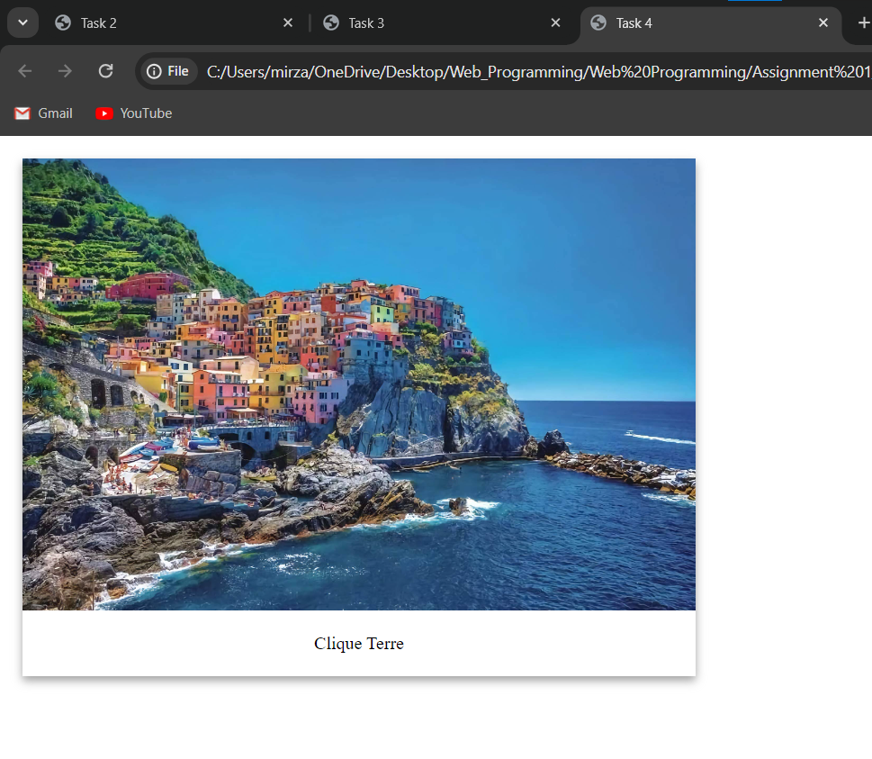

# TASK 5:

## Create your resume exactly as mentioned in provided video(Resume-a1.mp4) in your webpage.

## CODE:

## HTML:

<!DOCTYPE html>

<html lang="en">

<head>

    <meta charset="UTF-8">

    <meta name="viewport" content="width=device-width, initial-scale=1.0">

    <link rel="stylesheet" href="style5.css">

    <script src="https://kit.fontawesome.com/120dc2ca68.js" crossorigin="anonymous"></script>

    <title>Task 5</title>

</head>

<body>

    <header>

        <div class="Heading">

            <div class="name">

                <div class="namediv">

                    <h1>Mirza Sarim</h1>

                    <h2>Future Computer Scientist</h2>

                </div>

                <div class="imgdiv">

                    <img src="Sarim.jpg" alt="Image">

                </div>

            </div>

            <div class="LinksDiv">

                <a class="Links" href="https://github.com/MirzaSarim1" target="_blank">

                    <i class="fa-brands fa-github"></i>

                    GitHub</a>

                <a class="Links" href="mailto:mirzasarim.work@gmail.com" target="_blank">

                    <i class="fa-regular fa-envelope"></i>

                    mirzasarim.work@gmail.com</a>

                <a class="Links" id="end-link" href="https://www.linkedin.com/in/mirza-sarim-khalil-926360292/"

                    target="_blank">

                    <i class="fa-brands fa-linkedin"></i>

                    LinkedIn</a>

            </div>

        </div>

        <div class="InfoSections">

            <h1>About Me</h1>

            <p>I am a Computer Science Student At FAST NUCES cfd</p>

            <p>Currently, I am in 6th Semester</p>

        </div>

        <div class="InfoSections">

            <h1>Personal Information</h1>

            <ul>

                <li><b>Date of Birth :</b> September 23, 2001 </li>

                <li><b>Nationality :</b> Pakistan</li>

                <li><b>Address :</b> 1/30 Chenab Nagar, Chiniot</li>

                <li><b>Email :</b> mirzasarim.work@gmail.com</li>

                <li><b>Phone Number :</b> 01111010101</li>

            </ul>

        </div>

        <div class="InfoSections">

            <h1>Education</h1>

            <ul>

                <li><b>Degree:</b> Computer Science</li>

                <li><b>Institution:</b> FAST NUCES(CFD)</li>

                <li><b>Graduation Year:</b> 2025</li>

            </ul>

        </div>

        <div class="InfoSections">

            <h1>Work Experience</h1>

            <ul>

                <li><b>Freelance</b> Fiver</li>

            </ul>

        </div>

        <div class="InfoSections">

            <h1>My Projects</h1>

            <h3>Project 1</h3>

            <p>I developed Something</p>

            <a href="" target="_blank"><button class="button"><span>View Details</span></button></a>

            <h3>Project 2</h3>

            <p>I developed Something2</p>

            <a href="" target="_blank"><button class="button"><span>View Details</span></button></a>

        </div>

        <div class="InfoSections">

            <h1>Skills</h1>

            <ul>

                <li>C++/C#/Python/JS/PHP</li>

                <li>Graphics</li>

                <li>App Development</li>

            </ul>

        </div>

        <div class="ContactUS">

            <p>Contact me at mirzasarim.work@gmail.com</p>

        </div>

    </header>

    <section>

    </section>

</body>

</html>

## CSS:

.Heading {

    background-color: lightslategray;

    color: #fff;

    display: flex;

    flex-direction: column;

    align-items: center;

    height: 10%;

}

.name {

    display: flex;

    justify-content: center;

    margin-bottom: 20px;

}

.namediv {

    display: flex;

    flex-direction: column;

    margin-right: 20px;

}

.imgdiv {

    padding-top: 20px;

}

.imgdiv img {

    width: 130px;

    height: 140px;

    object-fit: cover;

    border: 3px solid lightgray;

    border-radius: 10px;

}

.LinksDiv {

    display: flex;

    gap: 15px;

}

.Links {

    text-decoration: none;

    color: white;

}

.InfoSections {

    box-shadow: 12px 10px 12px 10px rgba(46, 46, 46, 0.2);

    border-radius: 7px;

    margin: 20px;

    padding: 15px;

}

.InfoSections {

    transition: all 0.5s;

}

.InfoSections:hover {

    transform: scale(1.025);

}

.InfoSections h1 {

    font-size: 24px;

}

.InfoSections p {

    font-size: 16px;

}

.button {

    display: inline-block;

    border-radius: 4px;

    background-color: blue;

    border: solid 1px;

    border-color: blue;

    color: #FFFFFF;

    font-size: 12px;

    padding: 20px;

    width: 120px;

    transition: all 0.5s;

    cursor: pointer;

    padding-bottom: 100;

}

.button span {

    cursor: pointer;

    display: inline-block;

    position: relative;

    transition: 0.5s;

}

.button span:after {

    content: '\00bb';

    position: absolute;

    opacity: 0;

    top: 0;

    right: -20px;

    transition: 0.5s;

}

.button:hover span {

    padding-right: 8px;

}

.button:hover span:after {

    opacity: 1;

    right: 0;

}

.ContactUS {

    background-color: lightslategray;

    color: #fff;

    border-width: 10px;

    height: 100px;

}

.ContactUS p{

    padding-top: 20px;

    text-align: center;

    font-size: large;

}

## OUTPUT:

